**SAKARYA ÜNİVERSİTESİ**

**BİLGİSAYAR VE BİLİŞİM BİLİMLERİ FAKÜLTESİ**

**BİLGİSAYAR MÜHENDİSLİĞİ BÖLÜMÜ**

**VERİ YAPILARI ÖDEVİ**

**ÖĞRENCİ ADI: MAZHAR FURKAN ÇELEBİ**

**ÖĞRENCİ NO:G191210033**

**ÖĞRENİM:2.ÖĞRETİM**

**DERS GRUBU:C**

**ÖĞRETMEN ADI:Prof.Dr. Celal ÇEKEN**

**1)Uygulamanın Açıklaması:**

Yaptığım veritabanı ile oyun içerisindeki item ,hayvan , kahraman vb tarzda verilerin depolanabilmesini sağlamaya çalıştım.MMORPG tarzında bir oyunun veritabanının ilişkilendirdiğim tablolar faydalı olabilecek fonksiyon ve triggerlar kullanmaya çalıştım.

**2)İş Kuralları:**

**-**Bir kullanıcının karakteri yalnızca bir serverda olabilir.Bir serverda birden çok kullanıcı olabilir.

-Bir kullanıcı birden fazla serverda olabilir.

-Bir item birden çok kullanıcıda olabilir.Bir kullanıcı birden çok iteme sahip olabilir.

-Bir item birden fazla sunucuda olamaz.Bir sunucuda birden fazla item olabilir.

-Bir pet birden fazla kullanıcıda olabilir.Bir kullanıcıda birden fazla pet olamaz.

-Bir pet birden fazla serverda olabilir.Bir serverda birden çok pet olabilir.

-Bir guildde birden fazla kullanıcı olabilir.Bir kullanıcı yalnızca bir guilde katılabilir.

-Bir guild birden fazla sunucuda olamaz.Bir sunucuda birden fazla guild olabilir.

-Bir kullanıcı birden fazla leaderboardsta olamaz.Bir leaderboardsta birden fazla kullanıcı olabilir.

-Bir kullanıcı yalnızca bir item kuşanabilir .Bir item yalnızca bir oyuncu tarafından kuşanılabilir.

**3)İlişkisel Şema:**

-**Users(**id;int , k_ad i; character varying(50) , pass ; character varying(50) , email ; character varying(50))

**-Character(**id;int , character_name; character varying(50) , character_rolls; character varying(50)**)**

**-friend_List(**id;int,user_id;int ,friend_id;int **)**

**-guild(**id;int ,guild_id;int ,guild_name; character varying(50),guild_members;int**)**

**-guild_list(**id;int,guild_id;int,ch_id;int,user_id;int**)**

**-items(**id;int,item_id;int,item_name; character varying(50),item_rank; character varying(50),item_power;int,item_price;int**)**

**-leaderboards(**id;int,ch_id;int,user_id;int,user_power;int,user_name; character varying(50),user_character; character varying(50)**)**

**-pet(**id;int,pet_name; character varying(50),pet_power;int**)**

**-server_channel(**id;int,serverid;int,channel_id;int**)**

**-server_users(**id;int,user_id;int,ch_id;int**)**

**-servers(**id;int,serverid;int**)**

**-user_items(**id;int,user_id;int,ch_id;int,item_id;int**)**

**-users(**id;int,k_adi ; character varying(50),pass ; character varying(50),email ; character varying(50)**)**

**-users_character(**id;int,character_name; character varying(50),ch_id;int,user_id;int**)**

**-users_pet(**id;int,user_id;int,ch_id;int,pet_id;int**)**

**-users_power(**id;int,user_id;int,ch_id;int,userpower;int**)**

**4)Varlık Bağıntı Diyagramı:**

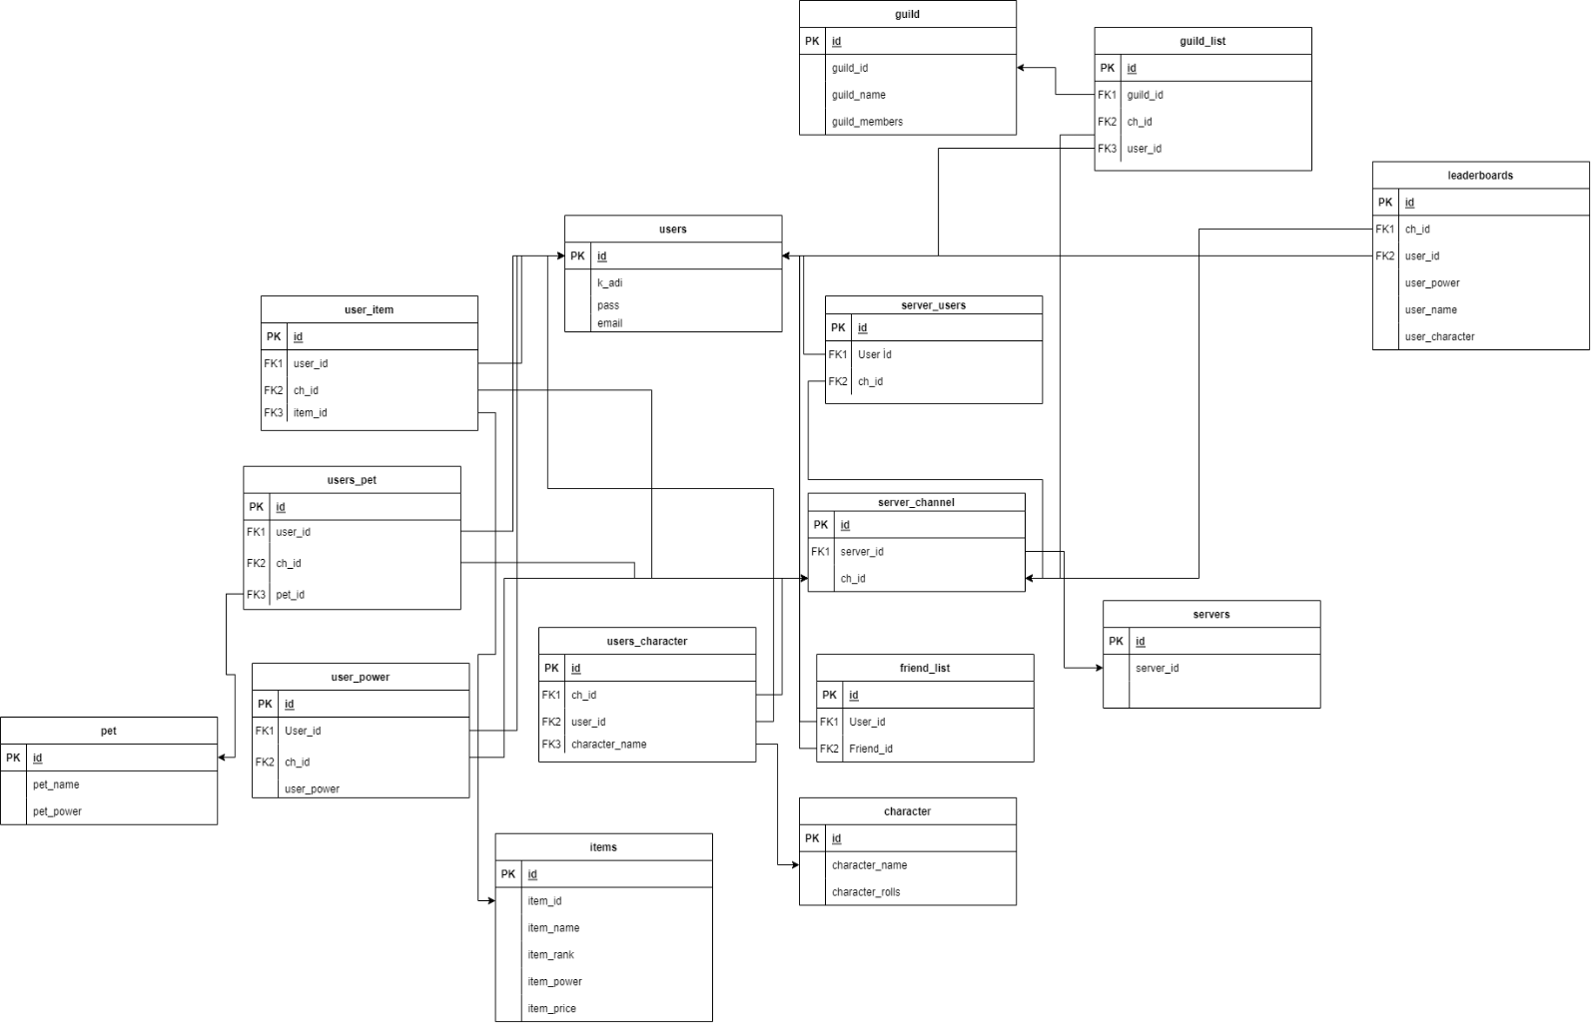

**5-Veritabanını Oluşturmayı Sağlayan SQL İfadeleri:**

--

-- PostgreSQL database dump

--

-- Dumped from database version 14.1

-- Dumped by pg_dump version 14.1

-- Started on 2021-12-20 20:35:46

SET statement_timeout = 0;

SET lock_timeout = 0;

SET idle_in_transaction_session_timeout = 0;

SET client_encoding = 'UTF8';

SET standard_conforming_strings = on;

SELECT pg_catalog.set_config('search_path', '', false);

SET check_function_bodies = false;

SET xmloption = content;

SET client_min_messages = warning;

SET row_security = off;

--

-- TOC entry 244 (class 1255 OID 18565)

-- Name: marketprice(double precision); Type: FUNCTION; Schema: public; Owner: postgres

--

CREATE FUNCTION public.marketprice(item_price double precision) RETURNS double precision

LANGUAGE plpgsql

AS $$

begin

item_price:=item_price*0.4;

return item_price;

end;

$$;

ALTER FUNCTION public.marketprice(item_price double precision) OWNER TO postgres;

--

-- TOC entry 245 (class 1255 OID 18566)

-- Name: toplamguc(integer, integer); Type: FUNCTION; Schema: public; Owner: postgres

--

CREATE FUNCTION public.toplamguc(s1 integer, s2 integer) RETURNS integer

LANGUAGE plpgsql

AS $$

declare

sonuc integer;

begin

sonuc:=s1+s2;

return sonuc;

end

$$;

ALTER FUNCTION public.toplamguc(s1 integer, s2 integer) OWNER TO postgres;

--

-- TOC entry 247 (class 1255 OID 18579)

-- Name: toplamitem(); Type: FUNCTION; Schema: public; Owner: postgres

--

CREATE FUNCTION public.toplamitem() RETURNS trigger

LANGUAGE plpgsql

AS $$

declare

itemsayisi integer;

begin

itemsayisi:=(select length(item_name) from items order by id desc limit 1);

update toplamlar set toplamitem=toplamitem+itemsayisi;

return new;

end;

$$;

ALTER FUNCTION public.toplamitem() OWNER TO postgres;

--

-- TOC entry 249 (class 1255 OID 18584)

-- Name: toplampet(); Type: FUNCTION; Schema: public; Owner: postgres

--

CREATE FUNCTION public.toplampet() RETURNS trigger

LANGUAGE plpgsql

AS $$

declare

petsayisi integer;

begin

petsayisi:=(select length(pet_name) from pet order by id desc limit 1);

update toplamlar set toplampet=toplampet+petsayisi;

return new;

end;

$$;

ALTER FUNCTION public.toplampet() OWNER TO postgres;

--

-- TOC entry 250 (class 1255 OID 18586)

-- Name: totalserver(); Type: FUNCTION; Schema: public; Owner: postgres

--

CREATE FUNCTION public.totalserver() RETURNS trigger

LANGUAGE plpgsql

AS $$

declare

serversayisi integer;

begin

serversayisi:=(select serverid from servers order by id desc limit 1);

update toplamlar set toplamserver=toplamserver+serversayisi;

return new;

end;

$$;

ALTER FUNCTION public.totalserver() OWNER TO postgres;

--

-- TOC entry 248 (class 1255 OID 18581)

-- Name: totalusers(); Type: FUNCTION; Schema: public; Owner: postgres

--

CREATE FUNCTION public.totalusers() RETURNS trigger

LANGUAGE plpgsql

AS $$

declare

kullanicisayisi integer;

begin

kullanicisayisi:=(select length(k_adi) from users order by id desc limit 1);

update toplamlar set toplamkullanici=toplamkullanici+kullanicisayisi;

return new;

end;

$$;

ALTER FUNCTION public.totalusers() OWNER TO postgres;

--

-- TOC entry 246 (class 1255 OID 18570)

-- Name: usergetir(character varying); Type: FUNCTION; Schema: public; Owner: postgres

--

CREATE FUNCTION public.usergetir(prmt character varying) RETURNS TABLE(idsutun integer, kadisutun character varying, passutun character varying)

LANGUAGE plpgsql

AS $$

begin

return query

select

id,

k_adi,

pass

from

users

where

k_adi like prmt;

end;

$$;

ALTER FUNCTION public.usergetir(prmt character varying) OWNER TO postgres;

SET default_tablespace = '';

SET default_table_access_method = heap;

--

-- TOC entry 233 (class 1259 OID 18230)

-- Name: character; Type: TABLE; Schema: public; Owner: postgres

--

CREATE TABLE public."character" (

id integer NOT NULL,

character_name character varying(50) NOT NULL,

character_rolls character varying(50) NOT NULL

);

ALTER TABLE public."character" OWNER TO postgres;

--

-- TOC entry 232 (class 1259 OID 18229)

-- Name: character_id_seq; Type: SEQUENCE; Schema: public; Owner: postgres

--

CREATE SEQUENCE public.character_id_seq

AS integer

START WITH 1

INCREMENT BY 1

NO MINVALUE

NO MAXVALUE

CACHE 1;

ALTER TABLE public.character_id_seq OWNER TO postgres;

--

-- TOC entry 3518 (class 0 OID 0)

-- Dependencies: 232

-- Name: character_id_seq; Type: SEQUENCE OWNED BY; Schema: public; Owner: postgres

--

ALTER SEQUENCE public.character_id_seq OWNED BY public."character".id;

--

-- TOC entry 226 (class 1259 OID 18180)

-- Name: friend_list; Type: TABLE; Schema: public; Owner: postgres

--

CREATE TABLE public.friend_list (

id integer NOT NULL,

user_id integer NOT NULL,

friend_id integer NOT NULL

);

ALTER TABLE public.friend_list OWNER TO postgres;

--

-- TOC entry 225 (class 1259 OID 18179)

-- Name: friend_list_id_seq; Type: SEQUENCE; Schema: public; Owner: postgres

--

CREATE SEQUENCE public.friend_list_id_seq

AS integer

START WITH 1

INCREMENT BY 1

NO MINVALUE

NO MAXVALUE

CACHE 1;

ALTER TABLE public.friend_list_id_seq OWNER TO postgres;

--

-- TOC entry 3519 (class 0 OID 0)

-- Dependencies: 225

-- Name: friend_list_id_seq; Type: SEQUENCE OWNED BY; Schema: public; Owner: postgres

--

ALTER SEQUENCE public.friend_list_id_seq OWNED BY public.friend_list.id;

--

-- TOC entry 229 (class 1259 OID 18198)

-- Name: guild; Type: TABLE; Schema: public; Owner: postgres

--

CREATE TABLE public.guild (

id integer NOT NULL,

guild_id integer NOT NULL,

guild_name character varying(50) NOT NULL,

guild_members integer NOT NULL

);

ALTER TABLE public.guild OWNER TO postgres;

--

-- TOC entry 228 (class 1259 OID 18197)

-- Name: guild_guild_id_seq; Type: SEQUENCE; Schema: public; Owner: postgres

--

CREATE SEQUENCE public.guild_guild_id_seq

AS integer

START WITH 1

INCREMENT BY 1

NO MINVALUE

NO MAXVALUE

CACHE 1;

ALTER TABLE public.guild_guild_id_seq OWNER TO postgres;

--

-- TOC entry 3520 (class 0 OID 0)

-- Dependencies: 228

-- Name: guild_guild_id_seq; Type: SEQUENCE OWNED BY; Schema: public; Owner: postgres

--

ALTER SEQUENCE public.guild_guild_id_seq OWNED BY public.guild.guild_id;

--

-- TOC entry 227 (class 1259 OID 18196)

-- Name: guild_id_seq; Type: SEQUENCE; Schema: public; Owner: postgres

--

CREATE SEQUENCE public.guild_id_seq

AS integer

START WITH 1

INCREMENT BY 1

NO MINVALUE

NO MAXVALUE

CACHE 1;

ALTER TABLE public.guild_id_seq OWNER TO postgres;

--

-- TOC entry 3521 (class 0 OID 0)

-- Dependencies: 227

-- Name: guild_id_seq; Type: SEQUENCE OWNED BY; Schema: public; Owner: postgres

--

ALTER SEQUENCE public.guild_id_seq OWNED BY public.guild.id;

--

-- TOC entry 231 (class 1259 OID 18208)

-- Name: guild_list; Type: TABLE; Schema: public; Owner: postgres

--

CREATE TABLE public.guild_list (

id integer NOT NULL,

guild_id integer NOT NULL,

ch_id integer NOT NULL,

user_id integer NOT NULL

);

ALTER TABLE public.guild_list OWNER TO postgres;

--

-- TOC entry 230 (class 1259 OID 18207)

-- Name: guild_list_id_seq; Type: SEQUENCE; Schema: public; Owner: postgres

--

CREATE SEQUENCE public.guild_list_id_seq

AS integer

START WITH 1

INCREMENT BY 1

NO MINVALUE

NO MAXVALUE

CACHE 1;

ALTER TABLE public.guild_list_id_seq OWNER TO postgres;

--

-- TOC entry 3522 (class 0 OID 0)

-- Dependencies: 230

-- Name: guild_list_id_seq; Type: SEQUENCE OWNED BY; Schema: public; Owner: postgres

--

ALTER SEQUENCE public.guild_list_id_seq OWNED BY public.guild_list.id;

--

-- TOC entry 220 (class 1259 OID 18131)

-- Name: items; Type: TABLE; Schema: public; Owner: postgres

--

CREATE TABLE public.items (

id integer NOT NULL,

item_id integer NOT NULL,

item_name character varying(50) NOT NULL,

item_rank character(3) NOT NULL,

item_power integer NOT NULL,

item_price integer NOT NULL

);

ALTER TABLE public.items OWNER TO postgres;

--

-- TOC entry 218 (class 1259 OID 18129)

-- Name: items_id_seq; Type: SEQUENCE; Schema: public; Owner: postgres

--

CREATE SEQUENCE public.items_id_seq

AS integer

START WITH 1

INCREMENT BY 1

NO MINVALUE

NO MAXVALUE

CACHE 1;

ALTER TABLE public.items_id_seq OWNER TO postgres;

--

-- TOC entry 3523 (class 0 OID 0)

-- Dependencies: 218

-- Name: items_id_seq; Type: SEQUENCE OWNED BY; Schema: public; Owner: postgres

--

ALTER SEQUENCE public.items_id_seq OWNED BY public.items.id;

--

-- TOC entry 219 (class 1259 OID 18130)

-- Name: items_item_id_seq; Type: SEQUENCE; Schema: public; Owner: postgres

--

CREATE SEQUENCE public.items_item_id_seq

AS integer

START WITH 1

INCREMENT BY 1

NO MINVALUE

NO MAXVALUE

CACHE 1;

ALTER TABLE public.items_item_id_seq OWNER TO postgres;

--

-- TOC entry 3524 (class 0 OID 0)

-- Dependencies: 219

-- Name: items_item_id_seq; Type: SEQUENCE OWNED BY; Schema: public; Owner: postgres

--

ALTER SEQUENCE public.items_item_id_seq OWNED BY public.items.item_id;

--

-- TOC entry 241 (class 1259 OID 18316)

-- Name: leaderboards; Type: TABLE; Schema: public; Owner: postgres

--

CREATE TABLE public.leaderboards (

id integer NOT NULL,

ch_id integer NOT NULL,

user_id integer NOT NULL,

user_power integer NOT NULL,

user_name character varying(50) NOT NULL,

user_character character varying(50) NOT NULL

);

ALTER TABLE public.leaderboards OWNER TO postgres;

--

-- TOC entry 240 (class 1259 OID 18315)

-- Name: leaderboards_id_seq; Type: SEQUENCE; Schema: public; Owner: postgres

--

CREATE SEQUENCE public.leaderboards_id_seq

AS integer

START WITH 1

INCREMENT BY 1

NO MINVALUE

NO MAXVALUE

CACHE 1;

ALTER TABLE public.leaderboards_id_seq OWNER TO postgres;

--

-- TOC entry 3525 (class 0 OID 0)

-- Dependencies: 240

-- Name: leaderboards_id_seq; Type: SEQUENCE OWNED BY; Schema: public; Owner: postgres

--

ALTER SEQUENCE public.leaderboards_id_seq OWNED BY public.leaderboards.id;

--

-- TOC entry 237 (class 1259 OID 18287)

-- Name: pet; Type: TABLE; Schema: public; Owner: postgres

--

CREATE TABLE public.pet (

id integer NOT NULL,

pet_name character varying(50) NOT NULL,

pet_power integer NOT NULL

);

ALTER TABLE public.pet OWNER TO postgres;

--

-- TOC entry 236 (class 1259 OID 18286)

-- Name: pet_id_seq; Type: SEQUENCE; Schema: public; Owner: postgres

--

CREATE SEQUENCE public.pet_id_seq

AS integer

START WITH 1

INCREMENT BY 1

NO MINVALUE

NO MAXVALUE

CACHE 1;

ALTER TABLE public.pet_id_seq OWNER TO postgres;

--

-- TOC entry 3526 (class 0 OID 0)

-- Dependencies: 236

-- Name: pet_id_seq; Type: SEQUENCE OWNED BY; Schema: public; Owner: postgres

--

ALTER SEQUENCE public.pet_id_seq OWNED BY public.pet.id;

--

-- TOC entry 215 (class 1259 OID 18099)

-- Name: server_channel; Type: TABLE; Schema: public; Owner: postgres

--

CREATE TABLE public.server_channel (

id integer NOT NULL,

serverid integer NOT NULL,

channel_id integer NOT NULL

);

ALTER TABLE public.server_channel OWNER TO postgres;

--

-- TOC entry 214 (class 1259 OID 18098)

-- Name: server_channel_id_seq; Type: SEQUENCE; Schema: public; Owner: postgres

--

CREATE SEQUENCE public.server_channel_id_seq

AS integer

START WITH 1

INCREMENT BY 1

NO MINVALUE

NO MAXVALUE

CACHE 1;

ALTER TABLE public.server_channel_id_seq OWNER TO postgres;

--

-- TOC entry 3527 (class 0 OID 0)

-- Dependencies: 214

-- Name: server_channel_id_seq; Type: SEQUENCE OWNED BY; Schema: public; Owner: postgres

--

ALTER SEQUENCE public.server_channel_id_seq OWNED BY public.server_channel.id;

--

-- TOC entry 217 (class 1259 OID 18113)

-- Name: server_users; Type: TABLE; Schema: public; Owner: postgres

--

CREATE TABLE public.server_users (

id integer NOT NULL,

user_id integer NOT NULL,

ch_id integer NOT NULL

);

ALTER TABLE public.server_users OWNER TO postgres;

--

-- TOC entry 216 (class 1259 OID 18112)

-- Name: server_users_id_seq; Type: SEQUENCE; Schema: public; Owner: postgres

--

CREATE SEQUENCE public.server_users_id_seq

AS integer

START WITH 1

INCREMENT BY 1

NO MINVALUE

NO MAXVALUE

CACHE 1;

ALTER TABLE public.server_users_id_seq OWNER TO postgres;

--

-- TOC entry 3528 (class 0 OID 0)

-- Dependencies: 216

-- Name: server_users_id_seq; Type: SEQUENCE OWNED BY; Schema: public; Owner: postgres

--

ALTER SEQUENCE public.server_users_id_seq OWNED BY public.server_users.id;

--

-- TOC entry 213 (class 1259 OID 18089)

-- Name: servers; Type: TABLE; Schema: public; Owner: postgres

--

CREATE TABLE public.servers (

id integer NOT NULL,

serverid integer NOT NULL

);

ALTER TABLE public.servers OWNER TO postgres;

--

-- TOC entry 211 (class 1259 OID 18087)

-- Name: servers_id_seq; Type: SEQUENCE; Schema: public; Owner: postgres

--

CREATE SEQUENCE public.servers_id_seq

AS integer

START WITH 1

INCREMENT BY 1

NO MINVALUE

NO MAXVALUE

CACHE 1;

ALTER TABLE public.servers_id_seq OWNER TO postgres;

--

-- TOC entry 3529 (class 0 OID 0)

-- Dependencies: 211

-- Name: servers_id_seq; Type: SEQUENCE OWNED BY; Schema: public; Owner: postgres

--

ALTER SEQUENCE public.servers_id_seq OWNED BY public.servers.id;

--

-- TOC entry 212 (class 1259 OID 18088)

-- Name: servers_serverid_seq; Type: SEQUENCE; Schema: public; Owner: postgres

--

CREATE SEQUENCE public.servers_serverid_seq

AS integer

START WITH 1

INCREMENT BY 1

NO MINVALUE

NO MAXVALUE

CACHE 1;

ALTER TABLE public.servers_serverid_seq OWNER TO postgres;

--

-- TOC entry 3530 (class 0 OID 0)

-- Dependencies: 212

-- Name: servers_serverid_seq; Type: SEQUENCE OWNED BY; Schema: public; Owner: postgres

--

ALTER SEQUENCE public.servers_serverid_seq OWNED BY public.servers.serverid;

--

-- TOC entry 243 (class 1259 OID 18572)

-- Name: toplamlar; Type: TABLE; Schema: public; Owner: postgres

--

CREATE TABLE public.toplamlar (

id integer NOT NULL,

toplamitem integer NOT NULL,

toplamkullanici integer NOT NULL,

toplampet integer NOT NULL,

toplamserver integer

);

ALTER TABLE public.toplamlar OWNER TO postgres;

--

-- TOC entry 242 (class 1259 OID 18571)

-- Name: toplamlar_id_seq; Type: SEQUENCE; Schema: public; Owner: postgres

--

CREATE SEQUENCE public.toplamlar_id_seq

AS integer

START WITH 1

INCREMENT BY 1

NO MINVALUE

NO MAXVALUE

CACHE 1;

ALTER TABLE public.toplamlar_id_seq OWNER TO postgres;

--

-- TOC entry 3531 (class 0 OID 0)

-- Dependencies: 242

-- Name: toplamlar_id_seq; Type: SEQUENCE OWNED BY; Schema: public; Owner: postgres

--

ALTER SEQUENCE public.toplamlar_id_seq OWNED BY public.toplamlar.id;

--

-- TOC entry 222 (class 1259 OID 18141)

-- Name: user_items; Type: TABLE; Schema: public; Owner: postgres

--

CREATE TABLE public.user_items (

id integer NOT NULL,

user_id integer NOT NULL,

ch_id integer NOT NULL,

item_id integer NOT NULL

);

ALTER TABLE public.user_items OWNER TO postgres;

--

-- TOC entry 221 (class 1259 OID 18140)

-- Name: user_items_id_seq; Type: SEQUENCE; Schema: public; Owner: postgres

--

CREATE SEQUENCE public.user_items_id_seq

AS integer

START WITH 1

INCREMENT BY 1

NO MINVALUE

NO MAXVALUE

CACHE 1;

ALTER TABLE public.user_items_id_seq OWNER TO postgres;

--

-- TOC entry 3532 (class 0 OID 0)

-- Dependencies: 221

-- Name: user_items_id_seq; Type: SEQUENCE OWNED BY; Schema: public; Owner: postgres

--

ALTER SEQUENCE public.user_items_id_seq OWNED BY public.user_items.id;

--

-- TOC entry 210 (class 1259 OID 18077)

-- Name: users; Type: TABLE; Schema: public; Owner: postgres

--

CREATE TABLE public.users (

id integer NOT NULL,

k_adi character varying(50) NOT NULL,

pass character varying(50) NOT NULL,

email character varying(50) NOT NULL

);

ALTER TABLE public.users OWNER TO postgres;

--

-- TOC entry 235 (class 1259 OID 18239)

-- Name: users_character; Type: TABLE; Schema: public; Owner: postgres

--

CREATE TABLE public.users_character (

id integer NOT NULL,

character_name character varying(50) NOT NULL,

ch_id integer NOT NULL,

user_id integer NOT NULL

);

ALTER TABLE public.users_character OWNER TO postgres;

--

-- TOC entry 234 (class 1259 OID 18238)

-- Name: users_character_id_seq; Type: SEQUENCE; Schema: public; Owner: postgres

--

CREATE SEQUENCE public.users_character_id_seq

AS integer

START WITH 1

INCREMENT BY 1

NO MINVALUE

NO MAXVALUE

CACHE 1;

ALTER TABLE public.users_character_id_seq OWNER TO postgres;

--

-- TOC entry 3533 (class 0 OID 0)

-- Dependencies: 234

-- Name: users_character_id_seq; Type: SEQUENCE OWNED BY; Schema: public; Owner: postgres

--

ALTER SEQUENCE public.users_character_id_seq OWNED BY public.users_character.id;

--

-- TOC entry 209 (class 1259 OID 18076)

-- Name: users_id_seq; Type: SEQUENCE; Schema: public; Owner: postgres

--

CREATE SEQUENCE public.users_id_seq

AS integer

START WITH 1

INCREMENT BY 1

NO MINVALUE

NO MAXVALUE

CACHE 1;

ALTER TABLE public.users_id_seq OWNER TO postgres;

--

-- TOC entry 3534 (class 0 OID 0)

-- Dependencies: 209

-- Name: users_id_seq; Type: SEQUENCE OWNED BY; Schema: public; Owner: postgres

--

ALTER SEQUENCE public.users_id_seq OWNED BY public.users.id;

--

-- TOC entry 239 (class 1259 OID 18294)

-- Name: users_pet; Type: TABLE; Schema: public; Owner: postgres

--

CREATE TABLE public.users_pet (

id integer NOT NULL,

user_id integer NOT NULL,

ch_id integer NOT NULL,

pet_id integer NOT NULL

);

ALTER TABLE public.users_pet OWNER TO postgres;

--

-- TOC entry 238 (class 1259 OID 18293)

-- Name: users_pet_id_seq; Type: SEQUENCE; Schema: public; Owner: postgres

--

CREATE SEQUENCE public.users_pet_id_seq

AS integer

START WITH 1

INCREMENT BY 1

NO MINVALUE

NO MAXVALUE

CACHE 1;

ALTER TABLE public.users_pet_id_seq OWNER TO postgres;

--

-- TOC entry 3535 (class 0 OID 0)

-- Dependencies: 238

-- Name: users_pet_id_seq; Type: SEQUENCE OWNED BY; Schema: public; Owner: postgres

--

ALTER SEQUENCE public.users_pet_id_seq OWNED BY public.users_pet.id;

--

-- TOC entry 224 (class 1259 OID 18163)

-- Name: users_power; Type: TABLE; Schema: public; Owner: postgres

--

CREATE TABLE public.users_power (

id integer NOT NULL,

user_id integer NOT NULL,

ch_id integer NOT NULL,

userpower integer NOT NULL

);

ALTER TABLE public.users_power OWNER TO postgres;

--

-- TOC entry 223 (class 1259 OID 18162)

-- Name: users_power_id_seq; Type: SEQUENCE; Schema: public; Owner: postgres

--

CREATE SEQUENCE public.users_power_id_seq

AS integer

START WITH 1

INCREMENT BY 1

NO MINVALUE

NO MAXVALUE

CACHE 1;

ALTER TABLE public.users_power_id_seq OWNER TO postgres;

--

-- TOC entry 3536 (class 0 OID 0)

-- Dependencies: 223

-- Name: users_power_id_seq; Type: SEQUENCE OWNED BY; Schema: public; Owner: postgres

--

ALTER SEQUENCE public.users_power_id_seq OWNED BY public.users_power.id;

--

-- TOC entry 3262 (class 2604 OID 18233)

-- Name: character id; Type: DEFAULT; Schema: public; Owner: postgres

--

ALTER TABLE ONLY public."character" ALTER COLUMN id SET DEFAULT nextval('public.character_id_seq'::regclass);

--

-- TOC entry 3258 (class 2604 OID 18183)

-- Name: friend_list id; Type: DEFAULT; Schema: public; Owner: postgres

--

ALTER TABLE ONLY public.friend_list ALTER COLUMN id SET DEFAULT nextval('public.friend_list_id_seq'::regclass);

--

-- TOC entry 3259 (class 2604 OID 18201)

-- Name: guild id; Type: DEFAULT; Schema: public; Owner: postgres

--

ALTER TABLE ONLY public.guild ALTER COLUMN id SET DEFAULT nextval('public.guild_id_seq'::regclass);

--

-- TOC entry 3260 (class 2604 OID 18202)

-- Name: guild guild_id; Type: DEFAULT; Schema: public; Owner: postgres

--

ALTER TABLE ONLY public.guild ALTER COLUMN guild_id SET DEFAULT nextval('public.guild_guild_id_seq'::regclass);

--

-- TOC entry 3261 (class 2604 OID 18211)

-- Name: guild_list id; Type: DEFAULT; Schema: public; Owner: postgres

--

ALTER TABLE ONLY public.guild_list ALTER COLUMN id SET DEFAULT nextval('public.guild_list_id_seq'::regclass);

--

-- TOC entry 3254 (class 2604 OID 18134)

-- Name: items id; Type: DEFAULT; Schema: public; Owner: postgres

--

ALTER TABLE ONLY public.items ALTER COLUMN id SET DEFAULT nextval('public.items_id_seq'::regclass);

--

-- TOC entry 3255 (class 2604 OID 18135)

-- Name: items item_id; Type: DEFAULT; Schema: public; Owner: postgres

--

ALTER TABLE ONLY public.items ALTER COLUMN item_id SET DEFAULT nextval('public.items_item_id_seq'::regclass);

--

-- TOC entry 3266 (class 2604 OID 18319)

-- Name: leaderboards id; Type: DEFAULT; Schema: public; Owner: postgres

--

ALTER TABLE ONLY public.leaderboards ALTER COLUMN id SET DEFAULT nextval('public.leaderboards_id_seq'::regclass);

--

-- TOC entry 3264 (class 2604 OID 18290)

-- Name: pet id; Type: DEFAULT; Schema: public; Owner: postgres

--

ALTER TABLE ONLY public.pet ALTER COLUMN id SET DEFAULT nextval('public.pet_id_seq'::regclass);

--

-- TOC entry 3252 (class 2604 OID 18102)

-- Name: server_channel id; Type: DEFAULT; Schema: public; Owner: postgres

--

ALTER TABLE ONLY public.server_channel ALTER COLUMN id SET DEFAULT nextval('public.server_channel_id_seq'::regclass);

--

-- TOC entry 3253 (class 2604 OID 18116)

-- Name: server_users id; Type: DEFAULT; Schema: public; Owner: postgres

--

ALTER TABLE ONLY public.server_users ALTER COLUMN id SET DEFAULT nextval('public.server_users_id_seq'::regclass);

--

-- TOC entry 3250 (class 2604 OID 18092)

-- Name: servers id; Type: DEFAULT; Schema: public; Owner: postgres

--

ALTER TABLE ONLY public.servers ALTER COLUMN id SET DEFAULT nextval('public.servers_id_seq'::regclass);

--

-- TOC entry 3251 (class 2604 OID 18093)

-- Name: servers serverid; Type: DEFAULT; Schema: public; Owner: postgres

--

ALTER TABLE ONLY public.servers ALTER COLUMN serverid SET DEFAULT nextval('public.servers_serverid_seq'::regclass);

--

-- TOC entry 3267 (class 2604 OID 18575)

-- Name: toplamlar id; Type: DEFAULT; Schema: public; Owner: postgres

--

ALTER TABLE ONLY public.toplamlar ALTER COLUMN id SET DEFAULT nextval('public.toplamlar_id_seq'::regclass);

--

-- TOC entry 3256 (class 2604 OID 18144)

-- Name: user_items id; Type: DEFAULT; Schema: public; Owner: postgres

--

ALTER TABLE ONLY public.user_items ALTER COLUMN id SET DEFAULT nextval('public.user_items_id_seq'::regclass);

--

-- TOC entry 3249 (class 2604 OID 18080)

-- Name: users id; Type: DEFAULT; Schema: public; Owner: postgres

--

ALTER TABLE ONLY public.users ALTER COLUMN id SET DEFAULT nextval('public.users_id_seq'::regclass);

--

-- TOC entry 3263 (class 2604 OID 18242)

-- Name: users_character id; Type: DEFAULT; Schema: public; Owner: postgres

--

ALTER TABLE ONLY public.users_character ALTER COLUMN id SET DEFAULT nextval('public.users_character_id_seq'::regclass);

--

-- TOC entry 3265 (class 2604 OID 18297)

-- Name: users_pet id; Type: DEFAULT; Schema: public; Owner: postgres

--

ALTER TABLE ONLY public.users_pet ALTER COLUMN id SET DEFAULT nextval('public.users_pet_id_seq'::regclass);

--

-- TOC entry 3257 (class 2604 OID 18166)

-- Name: users_power id; Type: DEFAULT; Schema: public; Owner: postgres

--

ALTER TABLE ONLY public.users_power ALTER COLUMN id SET DEFAULT nextval('public.users_power_id_seq'::regclass);

--

-- TOC entry 3502 (class 0 OID 18230)

-- Dependencies: 233

-- Data for Name: character; Type: TABLE DATA; Schema: public; Owner: postgres

--

COPY public."character" (id, character_name, character_rolls) FROM stdin;

1 Elf Nişancı

2 Cüce Demirci

3 Goblin Hırsız

4 İnsan Büyücü

5 Dev Savaşçı

\.

--

-- TOC entry 3495 (class 0 OID 18180)

-- Dependencies: 226

-- Data for Name: friend_list; Type: TABLE DATA; Schema: public; Owner: postgres

--

COPY public.friend_list (id, user_id, friend_id) FROM stdin;

1 1 2

\.

--

-- TOC entry 3498 (class 0 OID 18198)

-- Dependencies: 229

-- Data for Name: guild; Type: TABLE DATA; Schema: public; Owner: postgres

--

COPY public.guild (id, guild_id, guild_name, guild_members) FROM stdin;

1 10 GECE AKINCILARI 1

2 11 GECE BASKINCILARI 1

\.

--

-- TOC entry 3500 (class 0 OID 18208)

-- Dependencies: 231

-- Data for Name: guild_list; Type: TABLE DATA; Schema: public; Owner: postgres

--

COPY public.guild_list (id, guild_id, ch_id, user_id) FROM stdin;

1 10 24 1

2 11 25 2

\.

--

-- TOC entry 3489 (class 0 OID 18131)

-- Dependencies: 220

-- Data for Name: items; Type: TABLE DATA; Schema: public; Owner: postgres

--

COPY public.items (id, item_id, item_name, item_rank, item_power, item_price) FROM stdin;

1 124 thunder SS 1500 12000

2 125 dark gun A 700 3800

3 126 thunder(fake) C 100 200

5 2 Soulfire SSS 3650 30000

\.

--

-- TOC entry 3510 (class 0 OID 18316)

-- Dependencies: 241

-- Data for Name: leaderboards; Type: TABLE DATA; Schema: public; Owner: postgres

--

COPY public.leaderboards (id, ch_id, user_id, user_power, user_name, user_character) FROM stdin;

1 24 1 4500 darkslayer Elf

2 25 2 2300 darkslayer123456 Büyücü

\.

--

-- TOC entry 3506 (class 0 OID 18287)

-- Dependencies: 237

-- Data for Name: pet; Type: TABLE DATA; Schema: public; Owner: postgres

--

COPY public.pet (id, pet_name, pet_power) FROM stdin;

1 Kyuubi 3000

2 Ayı 800

3 Aslan 1500

5 Kara Yılan 2400

\.

--

-- TOC entry 3484 (class 0 OID 18099)

-- Dependencies: 215

-- Data for Name: server_channel; Type: TABLE DATA; Schema: public; Owner: postgres

--

COPY public.server_channel (id, serverid, channel_id) FROM stdin;

8 1245 24

9 1245 25

\.

--

-- TOC entry 3486 (class 0 OID 18113)

-- Dependencies: 217

-- Data for Name: server_users; Type: TABLE DATA; Schema: public; Owner: postgres

--

COPY public.server_users (id, user_id, ch_id) FROM stdin;

1 1 24

2 2 25

\.

--

-- TOC entry 3482 (class 0 OID 18089)

-- Dependencies: 213

-- Data for Name: servers; Type: TABLE DATA; Schema: public; Owner: postgres

--

COPY public.servers (id, serverid) FROM stdin;

1 1245

\.

--

-- TOC entry 3512 (class 0 OID 18572)

-- Dependencies: 243

-- Data for Name: toplamlar; Type: TABLE DATA; Schema: public; Owner: postgres

--

COPY public.toplamlar (id, toplamitem, toplamkullanici, toplampet, toplamserver) FROM stdin;

2 4 2 4 \N

\.

--

-- TOC entry 3491 (class 0 OID 18141)

-- Dependencies: 222

-- Data for Name: user_items; Type: TABLE DATA; Schema: public; Owner: postgres

--

COPY public.user_items (id, user_id, ch_id, item_id) FROM stdin;

1 1 24 124

2 2 25 126

3 2 25 125

\.

--

-- TOC entry 3479 (class 0 OID 18077)

-- Dependencies: 210

-- Data for Name: users; Type: TABLE DATA; Schema: public; Owner: postgres

--

COPY public.users (id, k_adi, pass, email) FROM stdin;

1 darkslayer dark dark@gmail.com\n

2 darkslayer123456 dark123456\n dark123456@gmail.com\n

6 furkan furkan12 furkan12@gmail.com

\.

--

-- TOC entry 3504 (class 0 OID 18239)

-- Dependencies: 235

-- Data for Name: users_character; Type: TABLE DATA; Schema: public; Owner: postgres

--

COPY public.users_character (id, character_name, ch_id, user_id) FROM stdin;

16 Elf 24 1

17 İnsan 25 2

\.

--

-- TOC entry 3508 (class 0 OID 18294)

-- Dependencies: 239

-- Data for Name: users_pet; Type: TABLE DATA; Schema: public; Owner: postgres

--

COPY public.users_pet (id, user_id, ch_id, pet_id) FROM stdin;

1 1 24 1

2 2 25 3

\.

--

-- TOC entry 3493 (class 0 OID 18163)

-- Dependencies: 224

-- Data for Name: users_power; Type: TABLE DATA; Schema: public; Owner: postgres

--

COPY public.users_power (id, user_id, ch_id, userpower) FROM stdin;

1 1 24 4500

2 2 25 2300

\.

--

-- TOC entry 3537 (class 0 OID 0)

-- Dependencies: 232

-- Name: character_id_seq; Type: SEQUENCE SET; Schema: public; Owner: postgres

--

SELECT pg_catalog.setval('public.character_id_seq', 5, true);

--

-- TOC entry 3538 (class 0 OID 0)

-- Dependencies: 225

-- Name: friend_list_id_seq; Type: SEQUENCE SET; Schema: public; Owner: postgres

--

SELECT pg_catalog.setval('public.friend_list_id_seq', 1, true);

--

-- TOC entry 3539 (class 0 OID 0)

-- Dependencies: 228

-- Name: guild_guild_id_seq; Type: SEQUENCE SET; Schema: public; Owner: postgres

--

SELECT pg_catalog.setval('public.guild_guild_id_seq', 1, false);

--

-- TOC entry 3540 (class 0 OID 0)

-- Dependencies: 227

-- Name: guild_id_seq; Type: SEQUENCE SET; Schema: public; Owner: postgres

--

SELECT pg_catalog.setval('public.guild_id_seq', 2, true);

--

-- TOC entry 3541 (class 0 OID 0)

-- Dependencies: 230

-- Name: guild_list_id_seq; Type: SEQUENCE SET; Schema: public; Owner: postgres

--

SELECT pg_catalog.setval('public.guild_list_id_seq', 2, true);

--

-- TOC entry 3542 (class 0 OID 0)

-- Dependencies: 218

-- Name: items_id_seq; Type: SEQUENCE SET; Schema: public; Owner: postgres

--

SELECT pg_catalog.setval('public.items_id_seq', 5, true);

--

-- TOC entry 3543 (class 0 OID 0)

-- Dependencies: 219

-- Name: items_item_id_seq; Type: SEQUENCE SET; Schema: public; Owner: postgres

--

SELECT pg_catalog.setval('public.items_item_id_seq', 8, true);

--

-- TOC entry 3544 (class 0 OID 0)

-- Dependencies: 240

-- Name: leaderboards_id_seq; Type: SEQUENCE SET; Schema: public; Owner: postgres

--

SELECT pg_catalog.setval('public.leaderboards_id_seq', 2, true);

--

-- TOC entry 3545 (class 0 OID 0)

-- Dependencies: 236

-- Name: pet_id_seq; Type: SEQUENCE SET; Schema: public; Owner: postgres

--

SELECT pg_catalog.setval('public.pet_id_seq', 5, true);

--

-- TOC entry 3546 (class 0 OID 0)

-- Dependencies: 214

-- Name: server_channel_id_seq; Type: SEQUENCE SET; Schema: public; Owner: postgres

--

SELECT pg_catalog.setval('public.server_channel_id_seq', 9, true);

--

-- TOC entry 3547 (class 0 OID 0)

-- Dependencies: 216

-- Name: server_users_id_seq; Type: SEQUENCE SET; Schema: public; Owner: postgres

--

SELECT pg_catalog.setval('public.server_users_id_seq', 2, true);

--

-- TOC entry 3548 (class 0 OID 0)

-- Dependencies: 211

-- Name: servers_id_seq; Type: SEQUENCE SET; Schema: public; Owner: postgres

--

SELECT pg_catalog.setval('public.servers_id_seq', 1, true);

--

-- TOC entry 3549 (class 0 OID 0)

-- Dependencies: 212

-- Name: servers_serverid_seq; Type: SEQUENCE SET; Schema: public; Owner: postgres

--

SELECT pg_catalog.setval('public.servers_serverid_seq', 1, false);

--

-- TOC entry 3550 (class 0 OID 0)

-- Dependencies: 242

-- Name: toplamlar_id_seq; Type: SEQUENCE SET; Schema: public; Owner: postgres

--

SELECT pg_catalog.setval('public.toplamlar_id_seq', 1, false);

--

-- TOC entry 3551 (class 0 OID 0)

-- Dependencies: 221

-- Name: user_items_id_seq; Type: SEQUENCE SET; Schema: public; Owner: postgres

--

SELECT pg_catalog.setval('public.user_items_id_seq', 3, true);

--

-- TOC entry 3552 (class 0 OID 0)

-- Dependencies: 234

-- Name: users_character_id_seq; Type: SEQUENCE SET; Schema: public; Owner: postgres

--

SELECT pg_catalog.setval('public.users_character_id_seq', 18, true);

--

-- TOC entry 3553 (class 0 OID 0)

-- Dependencies: 209

-- Name: users_id_seq; Type: SEQUENCE SET; Schema: public; Owner: postgres

--

SELECT pg_catalog.setval('public.users_id_seq', 6, true);

--

-- TOC entry 3554 (class 0 OID 0)

-- Dependencies: 238

-- Name: users_pet_id_seq; Type: SEQUENCE SET; Schema: public; Owner: postgres

--

SELECT pg_catalog.setval('public.users_pet_id_seq', 2, true);

--

-- TOC entry 3555 (class 0 OID 0)

-- Dependencies: 223

-- Name: users_power_id_seq; Type: SEQUENCE SET; Schema: public; Owner: postgres

--

SELECT pg_catalog.setval('public.users_power_id_seq', 3, true);

--

-- TOC entry 3301 (class 2606 OID 18237)

-- Name: character character_character_name_key; Type: CONSTRAINT; Schema: public; Owner: postgres

--

ALTER TABLE ONLY public."character"

ADD CONSTRAINT character_character_name_key UNIQUE (character_name);

--

-- TOC entry 3303 (class 2606 OID 18235)

-- Name: character character_pkey; Type: CONSTRAINT; Schema: public; Owner: postgres

--

ALTER TABLE ONLY public."character"

ADD CONSTRAINT character_pkey PRIMARY KEY (id);

--

-- TOC entry 3293 (class 2606 OID 18185)

-- Name: friend_list friend_list_pkey; Type: CONSTRAINT; Schema: public; Owner: postgres

--

ALTER TABLE ONLY public.friend_list

ADD CONSTRAINT friend_list_pkey PRIMARY KEY (id);

--

-- TOC entry 3295 (class 2606 OID 18206)

-- Name: guild guild_guild_id_key; Type: CONSTRAINT; Schema: public; Owner: postgres

--

ALTER TABLE ONLY public.guild

ADD CONSTRAINT guild_guild_id_key UNIQUE (guild_id);

--

-- TOC entry 3299 (class 2606 OID 18213)

-- Name: guild_list guild_list_pkey; Type: CONSTRAINT; Schema: public; Owner: postgres

--

ALTER TABLE ONLY public.guild_list

ADD CONSTRAINT guild_list_pkey PRIMARY KEY (id);

--

-- TOC entry 3297 (class 2606 OID 18204)

-- Name: guild guild_pkey; Type: CONSTRAINT; Schema: public; Owner: postgres

--

ALTER TABLE ONLY public.guild

ADD CONSTRAINT guild_pkey PRIMARY KEY (id);

--

-- TOC entry 3285 (class 2606 OID 18139)

-- Name: items items_item_id_key; Type: CONSTRAINT; Schema: public; Owner: postgres

--

ALTER TABLE ONLY public.items

ADD CONSTRAINT items_item_id_key UNIQUE (item_id);

--

-- TOC entry 3287 (class 2606 OID 18137)

-- Name: items items_pkey; Type: CONSTRAINT; Schema: public; Owner: postgres

--

ALTER TABLE ONLY public.items

ADD CONSTRAINT items_pkey PRIMARY KEY (id);

--

-- TOC entry 3311 (class 2606 OID 18321)

-- Name: leaderboards leaderboards_pkey; Type: CONSTRAINT; Schema: public; Owner: postgres

--

ALTER TABLE ONLY public.leaderboards

ADD CONSTRAINT leaderboards_pkey PRIMARY KEY (id);

--

-- TOC entry 3307 (class 2606 OID 18292)

-- Name: pet pet_pkey; Type: CONSTRAINT; Schema: public; Owner: postgres

--

ALTER TABLE ONLY public.pet

ADD CONSTRAINT pet_pkey PRIMARY KEY (id);

--

-- TOC entry 3279 (class 2606 OID 18106)

-- Name: server_channel server_channel_channel_id_key; Type: CONSTRAINT; Schema: public; Owner: postgres

--

ALTER TABLE ONLY public.server_channel

ADD CONSTRAINT server_channel_channel_id_key UNIQUE (channel_id);

--

-- TOC entry 3281 (class 2606 OID 18104)

-- Name: server_channel server_channel_pkey; Type: CONSTRAINT; Schema: public; Owner: postgres

--

ALTER TABLE ONLY public.server_channel

ADD CONSTRAINT server_channel_pkey PRIMARY KEY (id);

--

-- TOC entry 3283 (class 2606 OID 18118)

-- Name: server_users server_users_pkey; Type: CONSTRAINT; Schema: public; Owner: postgres

--

ALTER TABLE ONLY public.server_users

ADD CONSTRAINT server_users_pkey PRIMARY KEY (id);

--

-- TOC entry 3275 (class 2606 OID 18095)

-- Name: servers servers_pkey; Type: CONSTRAINT; Schema: public; Owner: postgres

--

ALTER TABLE ONLY public.servers

ADD CONSTRAINT servers_pkey PRIMARY KEY (id);

--

-- TOC entry 3277 (class 2606 OID 18097)

-- Name: servers servers_serverid_key; Type: CONSTRAINT; Schema: public; Owner: postgres

--

ALTER TABLE ONLY public.servers

ADD CONSTRAINT servers_serverid_key UNIQUE (serverid);

--

-- TOC entry 3313 (class 2606 OID 18577)

-- Name: toplamlar toplamlar_pkey; Type: CONSTRAINT; Schema: public; Owner: postgres

--

ALTER TABLE ONLY public.toplamlar

ADD CONSTRAINT toplamlar_pkey PRIMARY KEY (id);

--

-- TOC entry 3289 (class 2606 OID 18146)

-- Name: user_items user_items_pkey; Type: CONSTRAINT; Schema: public; Owner: postgres

--

ALTER TABLE ONLY public.user_items

ADD CONSTRAINT user_items_pkey PRIMARY KEY (id);

--

-- TOC entry 3305 (class 2606 OID 18244)

-- Name: users_character users_character_pkey; Type: CONSTRAINT; Schema: public; Owner: postgres

--

ALTER TABLE ONLY public.users_character

ADD CONSTRAINT users_character_pkey PRIMARY KEY (id);

--

-- TOC entry 3269 (class 2606 OID 18086)

-- Name: users users_email_key; Type: CONSTRAINT; Schema: public; Owner: postgres

--

ALTER TABLE ONLY public.users

ADD CONSTRAINT users_email_key UNIQUE (email);

--

-- TOC entry 3271 (class 2606 OID 18084)

-- Name: users users_k_adi_key; Type: CONSTRAINT; Schema: public; Owner: postgres

--

ALTER TABLE ONLY public.users

ADD CONSTRAINT users_k_adi_key UNIQUE (k_adi);

--

-- TOC entry 3309 (class 2606 OID 18299)

-- Name: users_pet users_pet_pkey; Type: CONSTRAINT; Schema: public; Owner: postgres

--

ALTER TABLE ONLY public.users_pet

ADD CONSTRAINT users_pet_pkey PRIMARY KEY (id);

--

-- TOC entry 3273 (class 2606 OID 18082)

-- Name: users users_pkey; Type: CONSTRAINT; Schema: public; Owner: postgres

--

ALTER TABLE ONLY public.users

ADD CONSTRAINT users_pkey PRIMARY KEY (id);

--

-- TOC entry 3291 (class 2606 OID 18168)

-- Name: users_power users_power_pkey; Type: CONSTRAINT; Schema: public; Owner: postgres

--

ALTER TABLE ONLY public.users_power

ADD CONSTRAINT users_power_pkey PRIMARY KEY (id);

--

-- TOC entry 3337 (class 2620 OID 18580)

-- Name: items trigger1; Type: TRIGGER; Schema: public; Owner: postgres

--

CREATE TRIGGER trigger1 AFTER INSERT ON public.items FOR EACH ROW EXECUTE FUNCTION public.toplamitem();

--

-- TOC entry 3335 (class 2620 OID 18582)

-- Name: users trigger2; Type: TRIGGER; Schema: public; Owner: postgres

--

CREATE TRIGGER trigger2 AFTER INSERT ON public.users FOR EACH ROW EXECUTE FUNCTION public.totalusers();

--

-- TOC entry 3338 (class 2620 OID 18585)

-- Name: pet trigger3; Type: TRIGGER; Schema: public; Owner: postgres

--

CREATE TRIGGER trigger3 AFTER INSERT ON public.pet FOR EACH ROW EXECUTE FUNCTION public.toplampet();

--

-- TOC entry 3336 (class 2620 OID 18587)

-- Name: servers trigger4; Type: TRIGGER; Schema: public; Owner: postgres

--

CREATE TRIGGER trigger4 AFTER INSERT ON public.servers FOR EACH ROW EXECUTE FUNCTION public.totalserver();

--

-- TOC entry 3323 (class 2606 OID 18191)

-- Name: friend_list friend_list_friend_id_fkey; Type: FK CONSTRAINT; Schema: public; Owner: postgres

--

ALTER TABLE ONLY public.friend_list

ADD CONSTRAINT friend_list_friend_id_fkey FOREIGN KEY (friend_id) REFERENCES public.users(id) ON DELETE CASCADE;

--

-- TOC entry 3322 (class 2606 OID 18186)

-- Name: friend_list friend_list_user_id_fkey; Type: FK CONSTRAINT; Schema: public; Owner: postgres

--

ALTER TABLE ONLY public.friend_list

ADD CONSTRAINT friend_list_user_id_fkey FOREIGN KEY (user_id) REFERENCES public.users(id) ON DELETE CASCADE;

--

-- TOC entry 3325 (class 2606 OID 18219)

-- Name: guild_list guild_list_ch_id_fkey; Type: FK CONSTRAINT; Schema: public; Owner: postgres

--

ALTER TABLE ONLY public.guild_list

ADD CONSTRAINT guild_list_ch_id_fkey FOREIGN KEY (ch_id) REFERENCES public.server_channel(channel_id) ON DELETE CASCADE;

--

-- TOC entry 3326 (class 2606 OID 18224)

-- Name: guild_list guild_list_guild_id_fkey; Type: FK CONSTRAINT; Schema: public; Owner: postgres

--

ALTER TABLE ONLY public.guild_list

ADD CONSTRAINT guild_list_guild_id_fkey FOREIGN KEY (guild_id) REFERENCES public.guild(guild_id) ON DELETE CASCADE;

--

-- TOC entry 3324 (class 2606 OID 18214)

-- Name: guild_list guild_list_user_id_fkey; Type: FK CONSTRAINT; Schema: public; Owner: postgres

--

ALTER TABLE ONLY public.guild_list

ADD CONSTRAINT guild_list_user_id_fkey FOREIGN KEY (user_id) REFERENCES public.users(id) ON DELETE CASCADE;

--

-- TOC entry 3333 (class 2606 OID 18322)

-- Name: leaderboards leaderboards_ch_id_fkey; Type: FK CONSTRAINT; Schema: public; Owner: postgres

--

ALTER TABLE ONLY public.leaderboards

ADD CONSTRAINT leaderboards_ch_id_fkey FOREIGN KEY (ch_id) REFERENCES public.server_channel(channel_id) ON DELETE CASCADE;

--

-- TOC entry 3334 (class 2606 OID 18327)

-- Name: leaderboards leaderboards_user_id_fkey; Type: FK CONSTRAINT; Schema: public; Owner: postgres

--

ALTER TABLE ONLY public.leaderboards

ADD CONSTRAINT leaderboards_user_id_fkey FOREIGN KEY (user_id) REFERENCES public.users(id) ON DELETE CASCADE;

--

-- TOC entry 3314 (class 2606 OID 18107)

-- Name: server_channel server_channel_serverid_fkey; Type: FK CONSTRAINT; Schema: public; Owner: postgres

--

ALTER TABLE ONLY public.server_channel

ADD CONSTRAINT server_channel_serverid_fkey FOREIGN KEY (serverid) REFERENCES public.servers(serverid);

--

-- TOC entry 3315 (class 2606 OID 18119)

-- Name: server_users server_users_ch_id_fkey; Type: FK CONSTRAINT; Schema: public; Owner: postgres

--

ALTER TABLE ONLY public.server_users

ADD CONSTRAINT server_users_ch_id_fkey FOREIGN KEY (ch_id) REFERENCES public.server_channel(channel_id) ON DELETE CASCADE;

--

-- TOC entry 3316 (class 2606 OID 18124)

-- Name: server_users server_users_user_id_fkey; Type: FK CONSTRAINT; Schema: public; Owner: postgres

--

ALTER TABLE ONLY public.server_users

ADD CONSTRAINT server_users_user_id_fkey FOREIGN KEY (user_id) REFERENCES public.users(id) ON DELETE CASCADE;

--

-- TOC entry 3317 (class 2606 OID 18147)

-- Name: user_items user_items_ch_id_fkey; Type: FK CONSTRAINT; Schema: public; Owner: postgres

--

ALTER TABLE ONLY public.user_items

ADD CONSTRAINT user_items_ch_id_fkey FOREIGN KEY (ch_id) REFERENCES public.server_channel(channel_id) ON DELETE CASCADE;

--

-- TOC entry 3319 (class 2606 OID 18157)

-- Name: user_items user_items_item_id_fkey; Type: FK CONSTRAINT; Schema: public; Owner: postgres

--

ALTER TABLE ONLY public.user_items

ADD CONSTRAINT user_items_item_id_fkey FOREIGN KEY (item_id) REFERENCES public.items(item_id) ON DELETE CASCADE;

--

-- TOC entry 3318 (class 2606 OID 18152)

-- Name: user_items user_items_user_id_fkey; Type: FK CONSTRAINT; Schema: public; Owner: postgres

--

ALTER TABLE ONLY public.user_items

ADD CONSTRAINT user_items_user_id_fkey FOREIGN KEY (user_id) REFERENCES public.users(id) ON DELETE CASCADE;

--

-- TOC entry 3328 (class 2606 OID 18250)

-- Name: users_character users_character_ch_id_fkey; Type: FK CONSTRAINT; Schema: public; Owner: postgres

--

ALTER TABLE ONLY public.users_character

ADD CONSTRAINT users_character_ch_id_fkey FOREIGN KEY (ch_id) REFERENCES public.server_channel(channel_id) ON DELETE CASCADE;

--

-- TOC entry 3329 (class 2606 OID 18255)

-- Name: users_character users_character_character_name_fkey; Type: FK CONSTRAINT; Schema: public; Owner: postgres

--

ALTER TABLE ONLY public.users_character

ADD CONSTRAINT users_character_character_name_fkey FOREIGN KEY (character_name) REFERENCES public."character"(character_name) ON DELETE CASCADE;

--

-- TOC entry 3327 (class 2606 OID 18245)

-- Name: users_character users_character_user_id_fkey; Type: FK CONSTRAINT; Schema: public; Owner: postgres

--

ALTER TABLE ONLY public.users_character

ADD CONSTRAINT users_character_user_id_fkey FOREIGN KEY (user_id) REFERENCES public.users(id) ON DELETE CASCADE;

--

-- TOC entry 3331 (class 2606 OID 18305)

-- Name: users_pet users_pet_ch_id_fkey; Type: FK CONSTRAINT; Schema: public; Owner: postgres

--

ALTER TABLE ONLY public.users_pet

ADD CONSTRAINT users_pet_ch_id_fkey FOREIGN KEY (ch_id) REFERENCES public.server_channel(channel_id) ON DELETE CASCADE;

--

-- TOC entry 3332 (class 2606 OID 18310)

-- Name: users_pet users_pet_pet_id_fkey; Type: FK CONSTRAINT; Schema: public; Owner: postgres

--

ALTER TABLE ONLY public.users_pet

ADD CONSTRAINT users_pet_pet_id_fkey FOREIGN KEY (pet_id) REFERENCES public.pet(id) ON DELETE CASCADE;

--

-- TOC entry 3330 (class 2606 OID 18300)

-- Name: users_pet users_pet_user_id_fkey; Type: FK CONSTRAINT; Schema: public; Owner: postgres

--

ALTER TABLE ONLY public.users_pet

ADD CONSTRAINT users_pet_user_id_fkey FOREIGN KEY (user_id) REFERENCES public.users(id) ON DELETE CASCADE;

--

-- TOC entry 3320 (class 2606 OID 18169)

-- Name: users_power users_power_ch_id_fkey; Type: FK CONSTRAINT; Schema: public; Owner: postgres

--

ALTER TABLE ONLY public.users_power

ADD CONSTRAINT users_power_ch_id_fkey FOREIGN KEY (ch_id) REFERENCES public.server_channel(channel_id) ON DELETE CASCADE;

--

-- TOC entry 3321 (class 2606 OID 18174)

-- Name: users_power users_power_user_id_fkey; Type: FK CONSTRAINT; Schema: public; Owner: postgres

--

ALTER TABLE ONLY public.users_power

ADD CONSTRAINT users_power_user_id_fkey FOREIGN KEY (user_id) REFERENCES public.users(id) ON DELETE CASCADE;

-- Completed on 2021-12-20 20:35:47

--

-- PostgreSQL database dump complete

--

**6-)Triggerlar**

1. İtem sayısı arttığı zaman veritabanındaki gerekli tablolara ekleme yapar.

declare

itemsayisi integer;

begin

itemsayisi:=(select length(item_name) from items order by id desc limit 1);

update toplamlar set toplamitem=toplamitem+itemsayisi;

return new;

end;

1. Pet sayısı arttığı zaman veritabanındaki gerekli tablolara ekleme yapar.

declare

petsayisi integer;

begin

petsayisi:=(select length(pet_name) from pet order by id desc limit 1);

update toplamlar set toplampet=toplampet+petsayisi;

return new;

end;

1. Toplam server sayısı arttığında veritabanındaki gerekli tablolara ekleme yapar

declare

serversayisi integer;

begin

serversayisi:=(select serverid from servers order by id desc limit 1);

update toplamlar set toplamserver=toplamserver+serversayisi;

return new;

end;

1. Toplam kullanıcı sayısı arttığında veritabanındaki gerekli tablolara ekleme yapar

declare

kullanicisayisi integer;

begin

kullanicisayisi:=(select length(k_adi) from users order by id desc limit 1);

update toplamlar set toplamkullanici=toplamkullanici+kullanicisayisi;

return new;

end;

**7-)Fonksiyonlar**

1. İtemi markette hızlı bir biçimde satmak isterse bu fonksiyon ile vergi alıyoruz

begin

item_price:=item_price*0.4;

return item_price;

end;

b-)

declare

sonuc integer;

begin

sonuc:=s1+s2;

return sonuc;

end

c-)İstenilen kıstılamalar ile çağrılmak istenen kullanıcıyı getirmek için kullanılan fonksiyon

begin

return query

select

id,

k_adi,

pass

from

users

where

k_adi like prmt;

end;

**8-)Ekleme silme güncelleme arama ekran Resimleri**

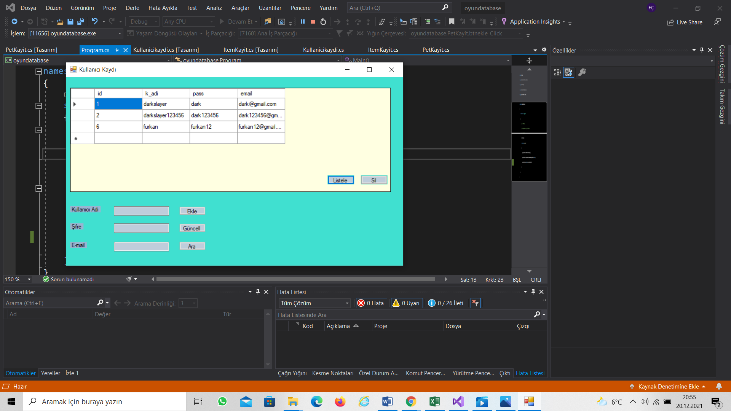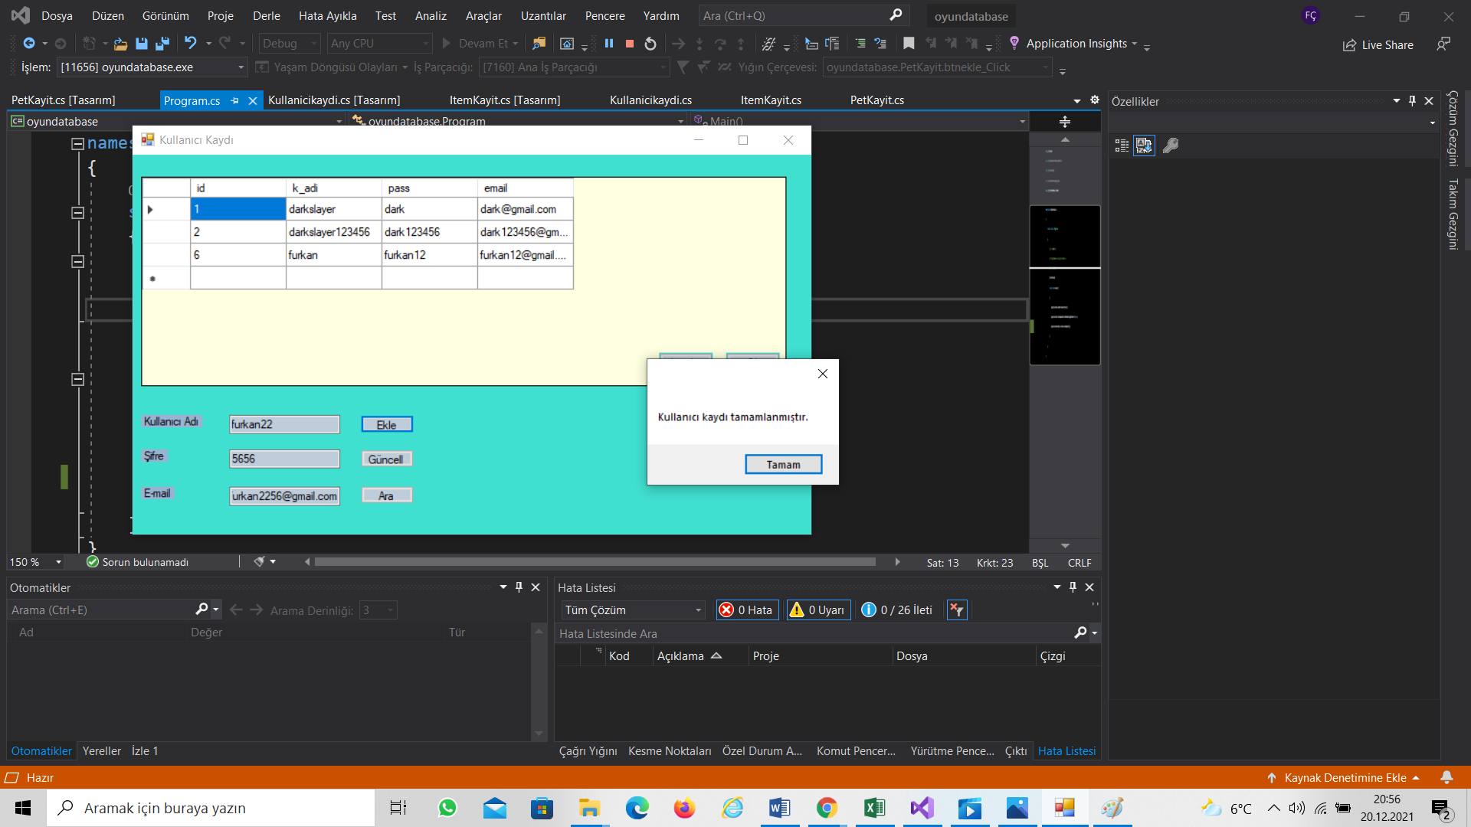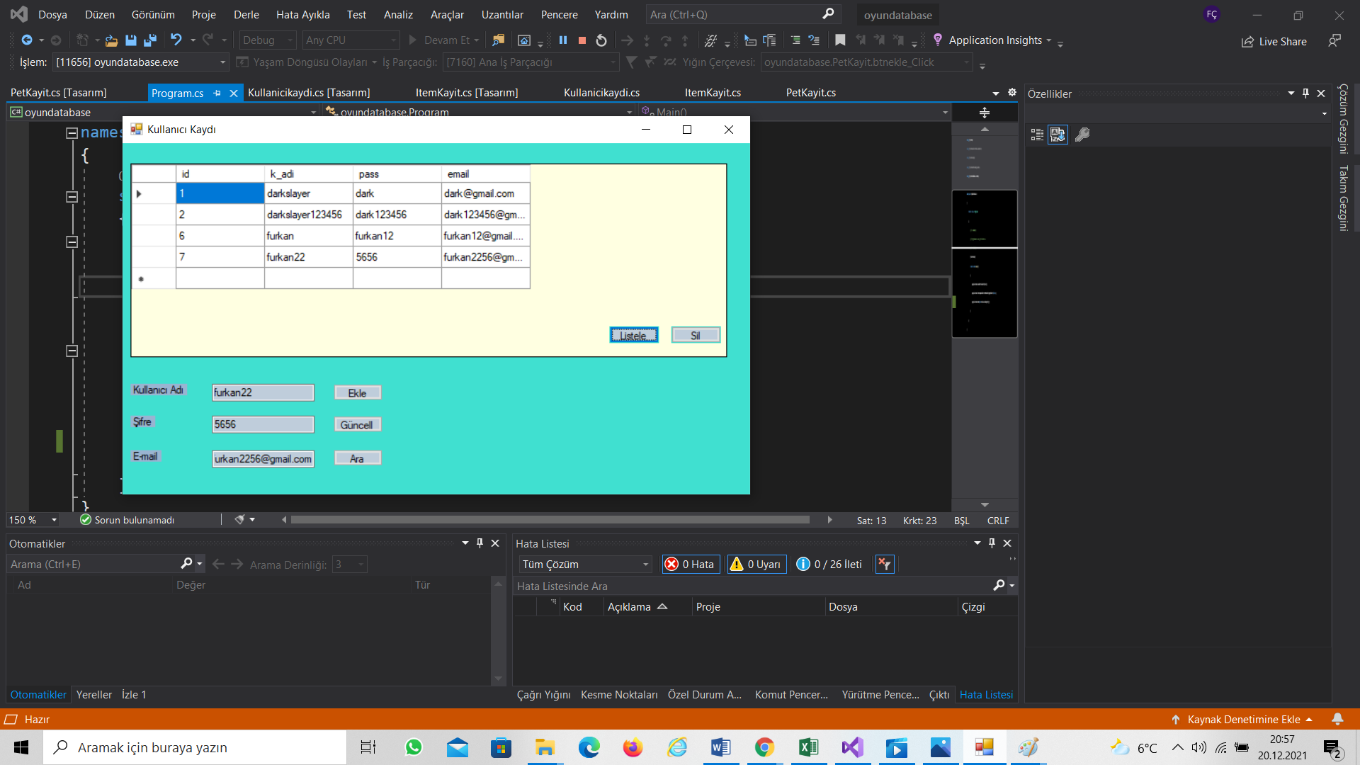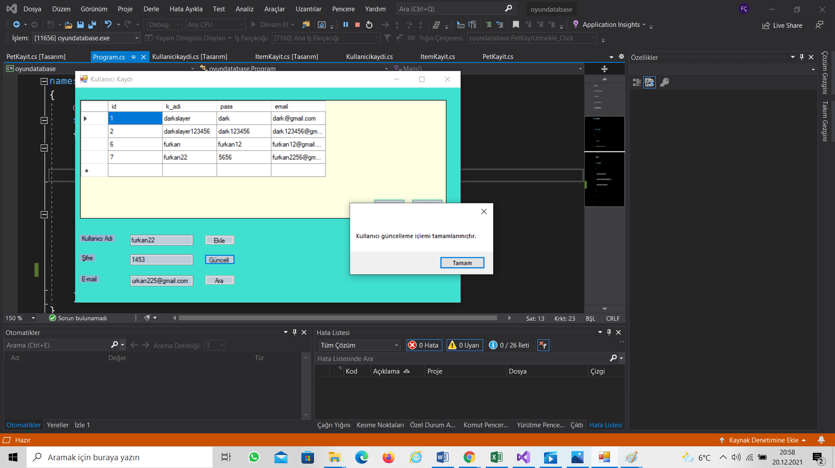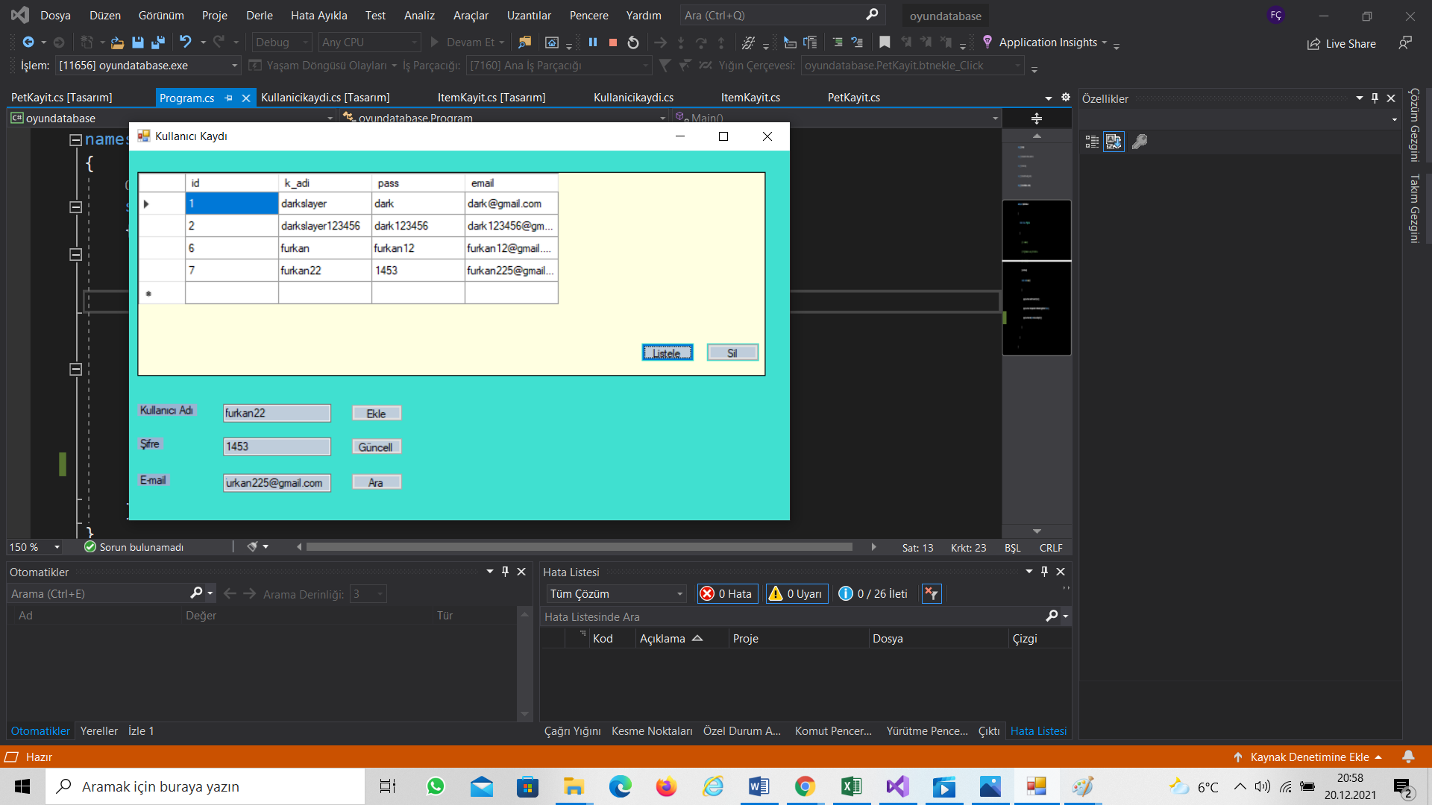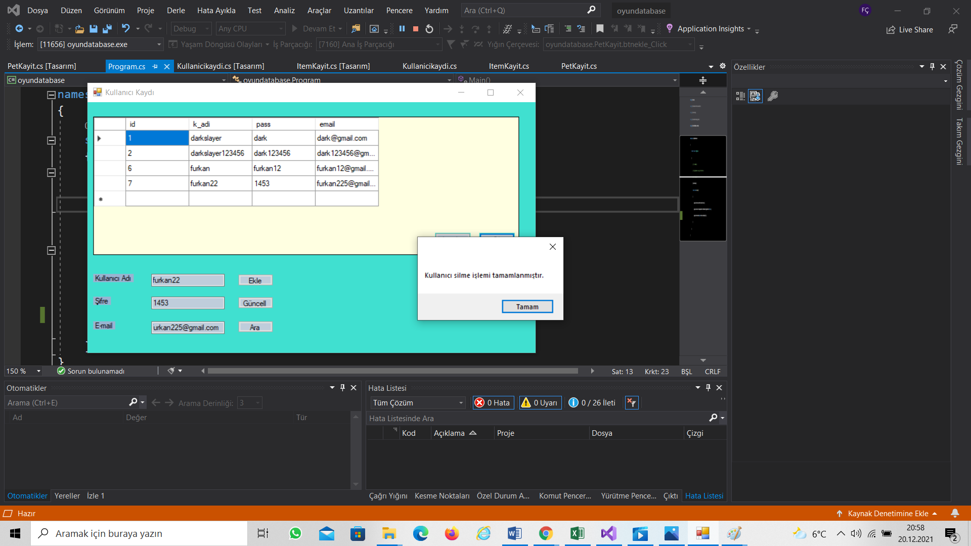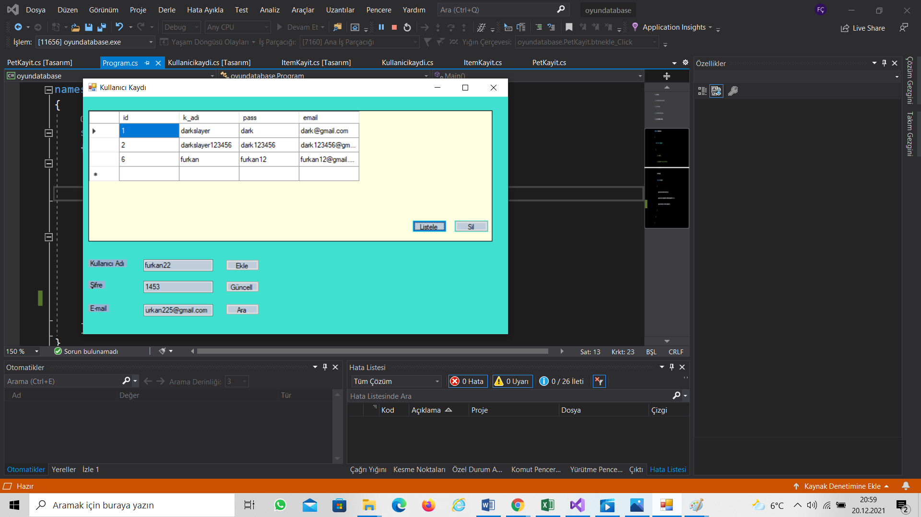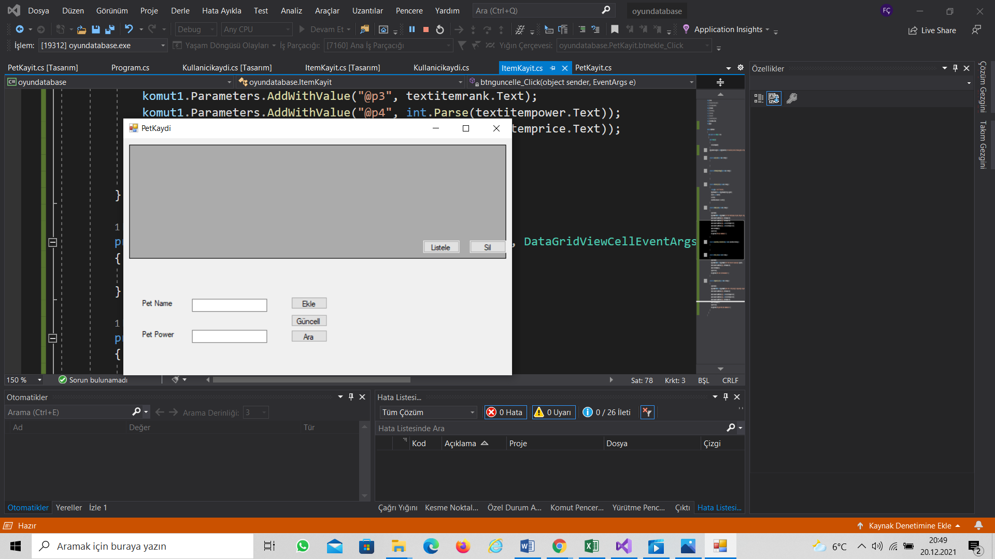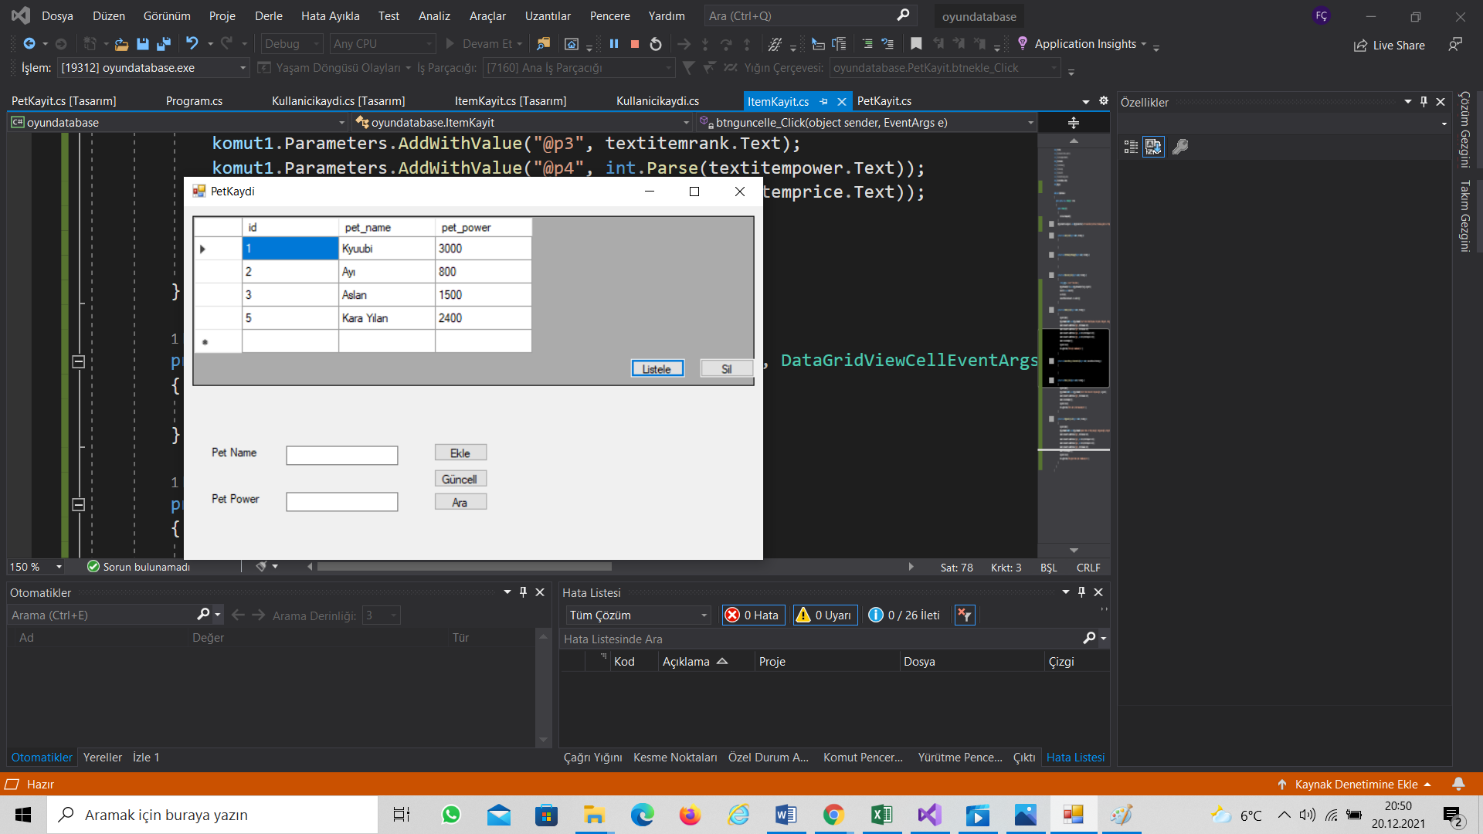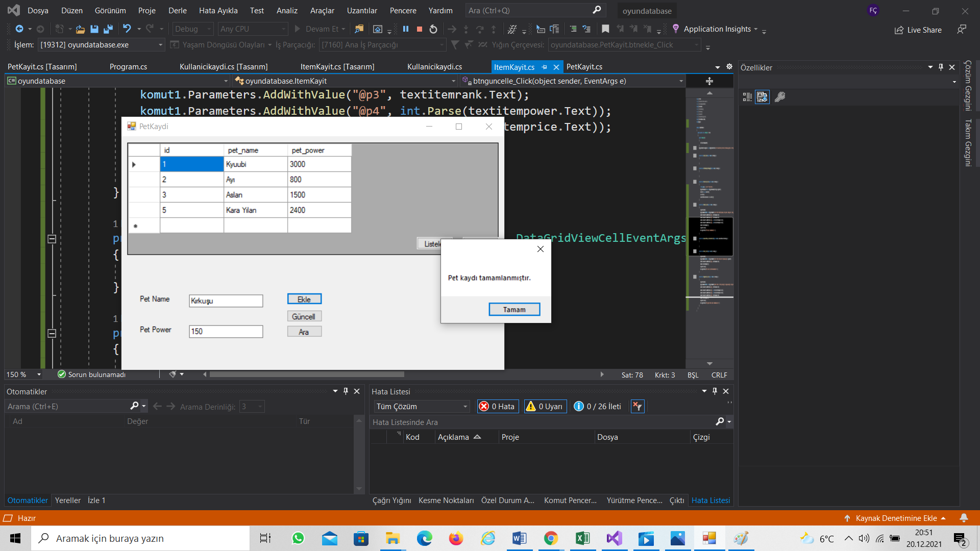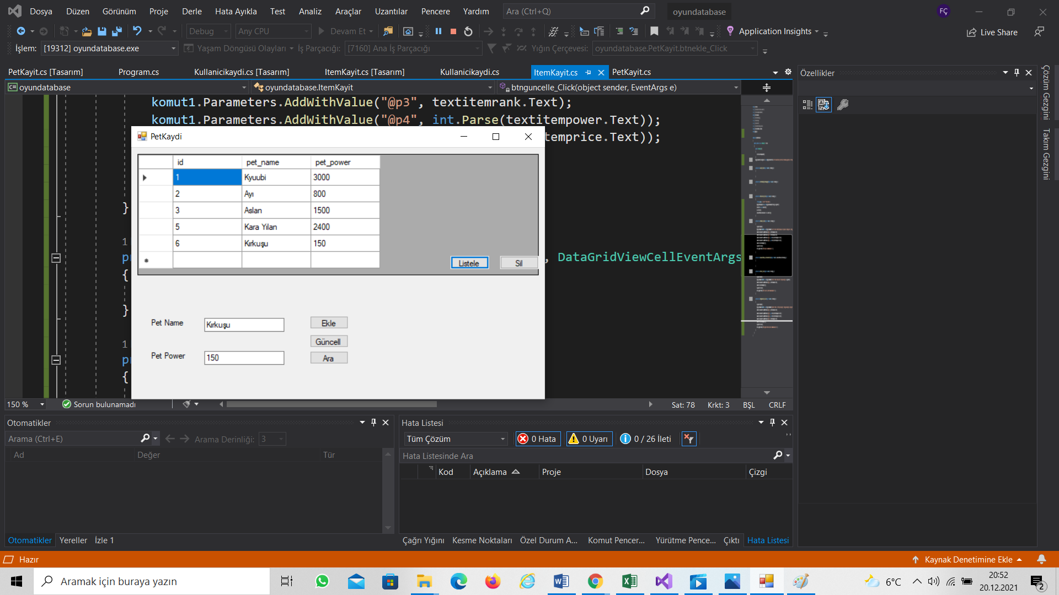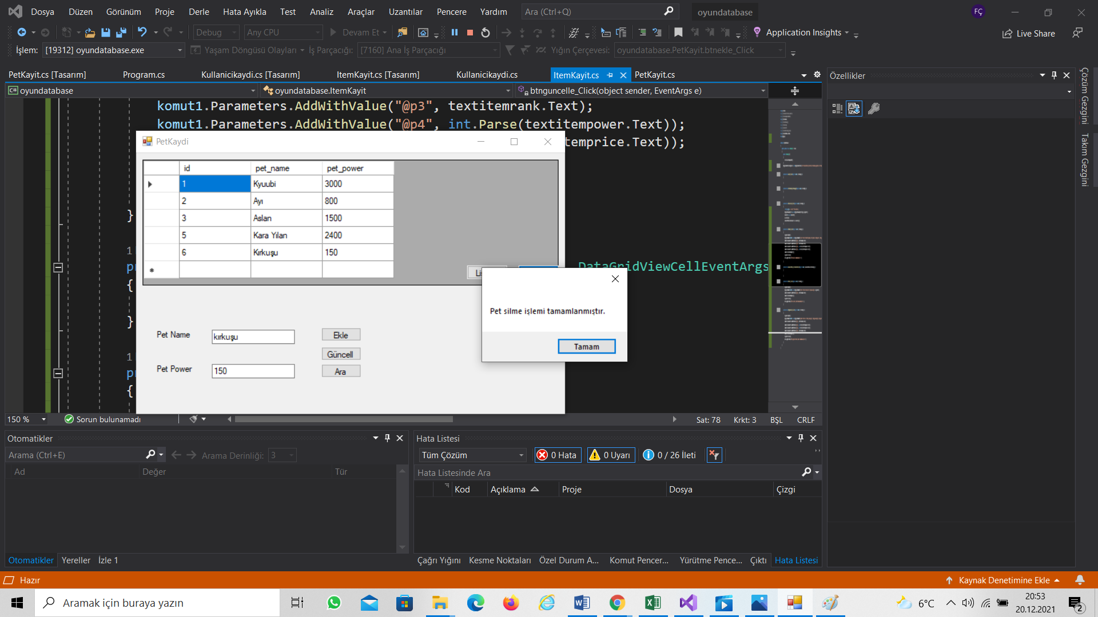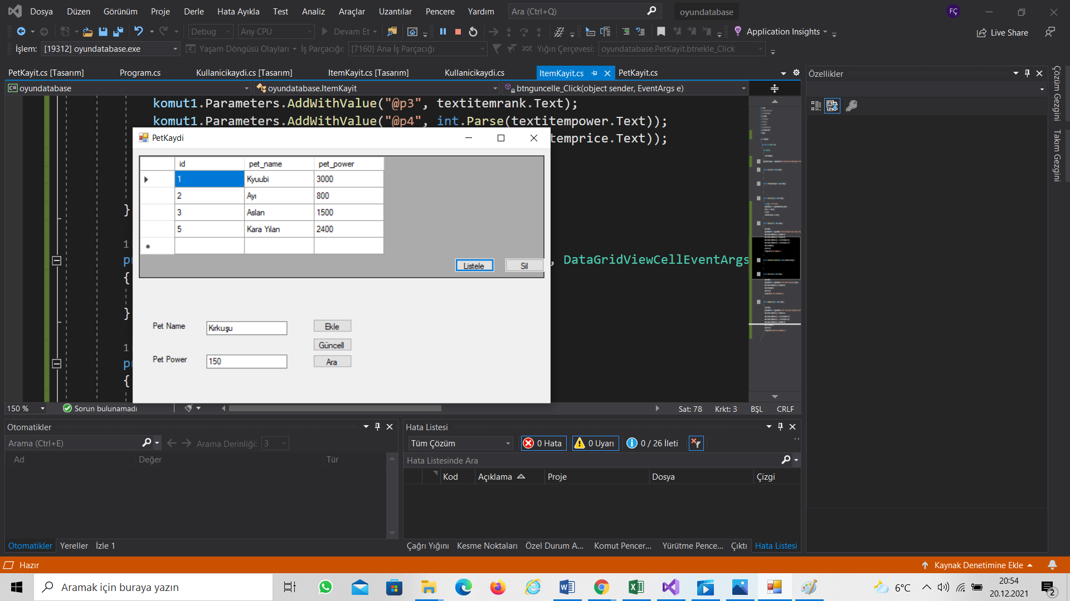

9-)Uygulamaya ait kaynak kodlar: